Project Title: Inode based File System

Project Team: Venkata Thippanna Rao.P.R 2005 145
Venu Madhav. A 2005 146
Vidyadhar. N 2005 147

Abstract:

The Project deals with simulation of the File system in Unix.
By Default the Block size that our system supports is 32 bytes. As it is a simulation we treated the data blocks to be only 2 in number (actually it is 10 data blocks + indirection blocks in Unix inodes ) to show the clear view of block reallocation in case of deletion of a particular file occupying some blocks.

The system supports directory hierarchies.

The operations that are to be supported on the file system as per specification includes
1 Make directory
2 Remove directory
3 Create file
4 Delete file
5 View file contents
6 View all files in a folder (with properties like inode no,size,owner)
7 Copy file contents to a different file
8 Traversing through the directory hierarchy.

And, our system supports the following commands
1. Make directory
2. Remove directory
3. Change directory
4. View directory
5. Make file
6. Remove file
7. View file
8. Copy file
9. Move or rename file
10. Root structure
11. Inode structure
12. Clear
13. Date
14. Disk free
15. Disk usage
16. Present working directory
17. Format disk
18. Help
19. About
20. Word count
21. Syntax
22. Quit
Design:
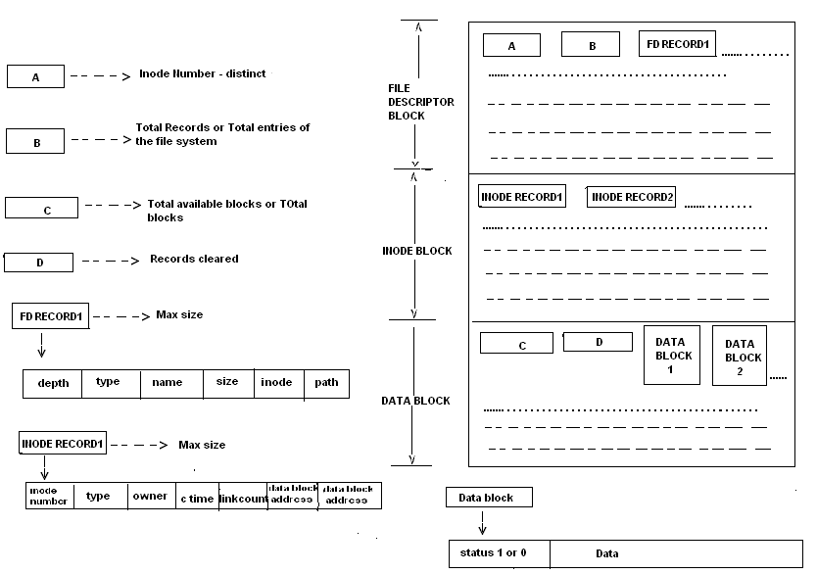
Inode number field A----- It is for the persistance of last inode number assigned.

Total Records B------------ This field is for retrieving the stored entries in the File Discriptor Block
and Inode Block.

Total Blocks C-------- It is for ensuring that the file system don’t overflow i.e. to make the
size of the filesystem to be constrained.

Records cleared D---------- This is to ensure that the free blocks be reallocated .While allocation
the system searches for the validation of D number of records.

Status of Data Block -------- Gives the validity, 1 for alive or 0 for dead. Made ‘0’ if the file holding
this data block is removed.

Size of the file system:

A file can be accommodated atmost in two data blocks and atleast in one data block. Directories wont occupy memory in data blocks.

Size of the file system = maximum size of directories + maximum size of files.

Maximum size of files = block size * total number of blocks.

Ex: maximum size of file=64*100.
maximum size of directories = 0.

Therefore size of the file system = block size * total number of blocks.

Ex: size of file system=64*100/1024 kb.

Brief Description:

Use ~ as argument to Bypass a command(Only for Some Commands as specified)

Directory Related Commands:
md <directory name> -- To Create a Directory(mkdir)
rd <directory name> -- To Remove an Empty Directory(rmdir)
cd <directory name> ,cd < / > ,cd <..> ,cd <.> ,cd <fullpath> -- To Change Directory(cd)
vd -- To View Contents of Directory(dir)
File Related Commands:
mf <file name> -- To Create a File(cat and copy con)
vf <file name> -- To View the Contents of File(cat and type)
rf <file name> -- To Remove a File(rm and del)
cf <sourcefile> <destinationfile> -- To Copy Contents fo source to destination(cp and copy)
mv <sourcefile> <destinationfile> -- To Rename a File(mv and ren)
wc <file name> -- To Calculate the Lines ans Words in a File(wc)
Disk Related Commands:
du -- To Display Disk Usage(INNOVATION,du)
df -- To Display Disk Free(INNOVATION,df)
ft -- To Format the Disk(format)
File System Structure Related Commands:
rs -- To View the Root Structure or File Descriptor Block(INNOVATION,tree)
is -- To View the Inode Structure(INNOVATION)
Miscellanous Commands:
cl -- To Clear the Screen Buffer(clear,cls)
dt -- To Display Date(date,time)
pd -- To Display the Current Working Directory(pwd)
Commands to Know Author and Quit:
at -- To Display About the Version Related Details(ver)
qt -- To Quit or Logout(logout,exit,quit)
Commands for Help:
h -- To Display Help on Commands(?,--h,man)
s <command> -- To Display Help on Individaul Commands(--h,?)
These Commands are Case Insensitive

Commands and Examples:

Make Directory:
md <directory name> -- To Create a Directory(mkdir)

EX:
md venki--creates directory venki in the current directory,
Gives error message if a directory lready exists!

Remove Directory:
rd <directory name> -- To Remove an Empty Directory(rmdir)

EX:
rd venki -- removes directory named venki if it exists in current working directory

Change Directory:
cd <directory name> ,cd < / > ,cd <..> ,cd <.> ,cd <fullpath> -- To Change Directory(cd)

EX:
cd . -- retains prompt in the current directory
cd .. -- Goes in to the Parent Directory
cd venki -- goes on directory named "venki" if it exists in the current directory
else displays error message
cd / -- goes to the root directory
cd IBFS/venki/naidu -- goes to specified directory if complete path is specified exists

View Directory:
vd -- To View Contents of Directory(dir)

EX:
vd -- lists the contents of current working directory

Create File:
mf <file name> -- To Create a File(cat and copy con)

EX:
mf venki.txt -- creates a file with the specified name, Gives error message if it exists

Remove File:
rf <file name> -- To Remove a File(rm and del)

EX:
rf venki.txt -- removes file specified if it exists in current directory else error message

Copy File:
cf <sourcefile> <destinationfile> -- To Copy Contents fo source to destination(cp and copy)

EX:
cp venki.txt dest.txt -- copies the file venki.txt to dest.txt if venki.txt exists else error message
displays if dest.txt already exists

Move File:
mv <sourcefile> <destinationfile> -- To Rename a File(mv and ren)

EX:
mv venki.txt dest.txt -- renames the file venki.txt to dest.txt if venki.txt exists else error message
displays if dest.txt already exists

Word Count:
wc <file name> -- To Calculate the Lines ans Words in a File(wc)

EX:
wc venki.txt -- gives the number of lines and words in the file if it exists else error message

Disk Usage:
du -- To Display Disk Usage(INNOVATION,du)

EX:
du -- displays the usage blocks by files with 134537766sage and internal fragmentation

Disk Free:
df -- To Display Disk Free(INNOVATION,df)

EX:
df -- displays the available blocks for data relevant information

Format:
ft -- To Format the Disk(format)

EX:
ft -- queries for formatting the disk y to format and anything else to skip

Root Structure:
rs -- To View the Root Structure or File Descriptor Block(INNOVATION,tree)

EX:
rs -- (root structure) displays the contents of the file system with relevant details

Inode Structure:
is -- To View the Inode Structure(INNOVATION)

EX:
is -- (inode structure) displays the contents of the inode part of the file system

Clear Screen Buffer:
cl -- To Clear the Screen Buffer(clear,cls)

EX:
cl -- clears the screen buffer

Date:
dt -- To Display Date(date,time)

EX:
dt -- displays the current date and time

Present Working Directory:
pd -- To Display the Current Working Directory(pwd)

EX:
pd -- displays the current working directory

About:
at -- To Display About the Version Related Details(ver)

EX:
at -- gives the information about the authors

Quit:
qt -- To Quit or Logout(logout,exit,quit)

EX:
qt -- quits from the shell

Help:
h -- To Display Help on Commands(?,--h,man)

EX:
h -- diplays the available commands in the shell

Syntax:
s <command> -- To Display Help on Individaul Commands(--h,?)

EX:
s md -- gives the mini man page related to command "md"

---------------------------------Thank You--------------------------------------------

